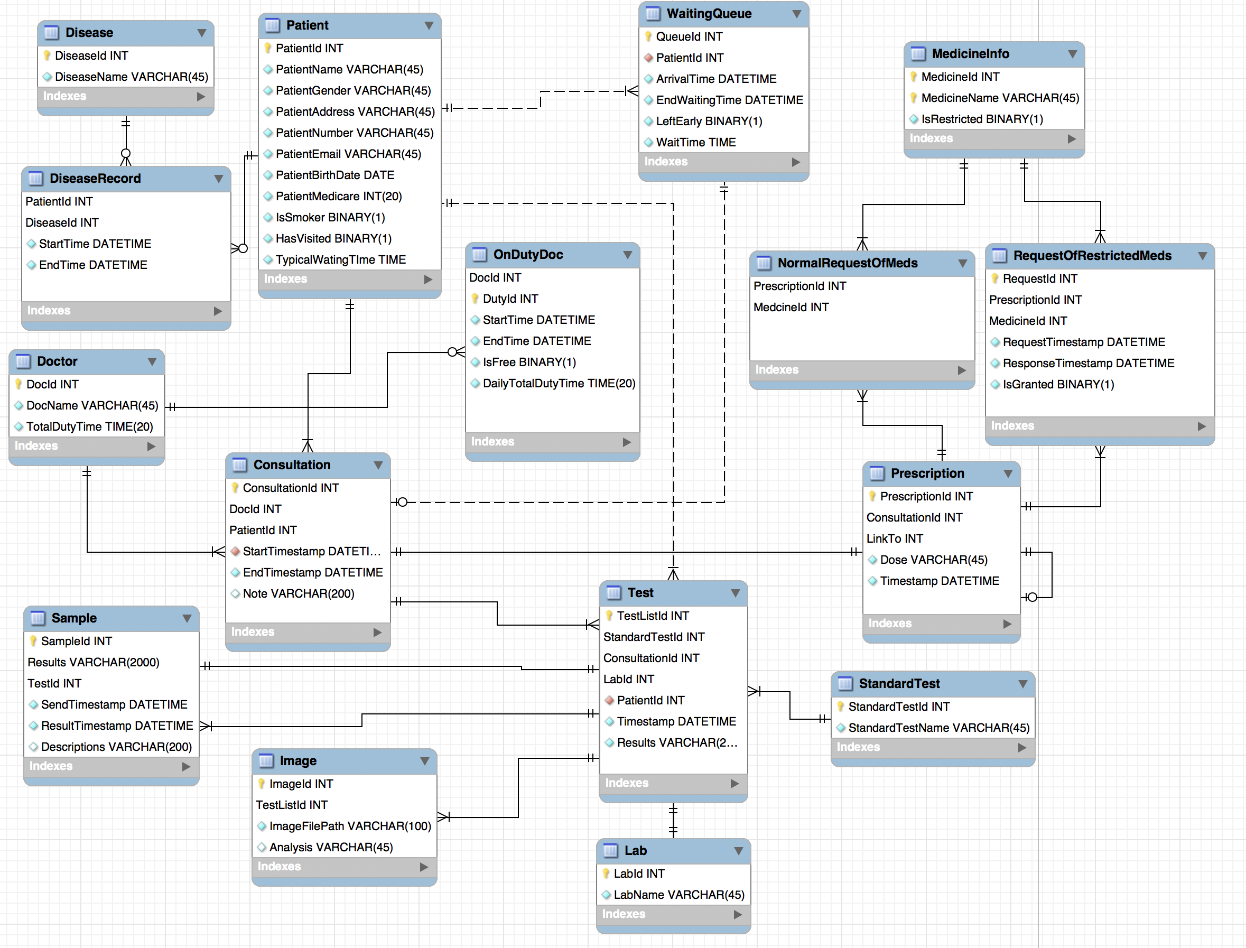

Data Dictionary
Entity 'Patient'
This is a table that holds patients’ information after registering into the system. Patients who have been to the clinic will have two extra attributes which are ‘HasVisited’ and ‘TypicalTime’ and they can simply sign in by using their patient id and birthdate.
Attribute | Description
PatientId | This is the primary key of entity ‘patient’. It is a unique integer for one specific patient and it is issued by the system once the patient complete registration. Then next time the patient comes, he can use it for signing in.
PatientName | The name of the patient, and it’s usually a string, e.g. ‘Benjamin Li’, varchar. Repetition is allowed.
PatientGender | The gender of the patient, binary. ‘1’ represents male and ‘0’ represents female.
PatientAddress | This field holds the address of patients, a string e.g. ‘746 Swanston St.’, varchar. Since some patients could be roommates, it’s not unique.
PatientNumber | The phone number of the patient. No longer than an eleven-digit number, but the data type is varchar.
PatientEmail | Holds the email address of the patient e.g. ‘jili@gmail.com’, varchar.
PatientBirthDate | The birthdate of the patient e.g. ‘1995-12-03’, date. After the registration, the birthdate will be used as password of the account. So, birthdate will then be converted into an 8-digit number e.g. ‘19951203’.
PatientMedicare | The unique 20-digit number of every patient, integer and unique.
IsSmoker | A binary number ‘0’ and ‘1’ means ‘Not a smoker’ and ‘Is a smoker’, respectively. This will help to build up the record of the patient.
HasVisited | A binary number ‘1’ and ‘0’ means ‘Has visited before’ and ‘has not visited before’, respectively. Those with the value ‘1’ need no registration and can simply sign in.
TypicalTime | This holds statistics of how long a patient usually wait until their consultation starts. The information will be updated every few months according to the data from another entity ‘WaitingQueue’.

Entity 'DiseaseRecord'
A record of information about patients’ diseases, including the time when it was recorded(added) and when they were recovered from it. Sometimes there could be no disease record of a patient so the foreign key on this side is not mandatory.
Attribute | Description
PatientId | This is the first foreign key and primary key of entity ‘DiseaseRecord’. It is a unique integer for one specific patient and it links to the attribute ‘PatientId’ in entity ‘Patient’.
DiseaseId | This is the second foreign key and primary key of entity ‘DiseaseRecord’. It is a unique integer for a type of disease and it links to the attribute ‘DiseaseId’ in entity ‘Disease’ which holds more than 300 different names of diseases. Together PatientId and DiseaseId help to identify a unique row of data.
StartTime | The time when the disease was recorded e.g. ‘2017-04-22 08:00:00’, datetime.
EndTime | The time when the disease was cured e.g. ‘2017-05-21 09:00:00’, datetime.

Entity 'Disease'
A table that holds more than 300 different normative names of diseases. It should be static.
Attribute | Description
DiseaseId | This is the primary key of entity ‘Disease’, integer.
DiseaseName | Data type is varchar, the name of the disease e.g. ‘Migraine’.

Entity 'WaitingQueue'
After the registering/signing in, patients will come to the queue and wait for the consultation. The entity includes the arrival time, consultation starting time and if the patient leaves before the consultation to calculate the typical waiting time. It is noteworthy that a patient can come to the queue and leave and then come again, so each time the patient should be issued an unique waiting number which in this case is ‘QueueId’.
Attributes | Description
QueueId | This is the primary key of entity ‘WaitingQueue’, integer.
PatientId | The second foreign key related to the attribute ‘PatientId’ in entity of ‘Patient’, integer.
ArrivalTime | The time when a patient gets into the queue e.g. ‘2018-07-10 10:00:00’, datetime. It will be later used to calculate the typical arrival time and waiting time.
EndWaitingTime | The time when patients stop waiting and are called for the consultation e.g. ‘2018-07-10 11:00:00’, datetime. It’s also recorded for counting the typical arrival time.
LeftEarly | A binary number ‘0’ and ‘1’ means ‘hasn’t left’ and ‘has left’, respectively. This will help to build a record of whether the patient leaves and if they have left then the system will ignore them and call the next patient.
WaitTime | Waiting time is the gap between ‘EndWaitingTime’ and ‘ArrivalTime’. Every few months the average value will be exported to the ‘TypicalTime’ in ‘Patient’ entity.

Entity 'Doctor'
The collection of all doctors, whether they are on duty or not. Currently, there are 20 doctors in this clinic, and the number is expected to be around 100 doctors in the clinic over the life of the clinic.
Attribute | Description
DocId | This is the primary key of entity ‘Doctor’, a unique integer.
DocName | This is the name of the doctor and it is a repeatable varchar.
TotalDutyTime | Holds the amount of doctor’s duty time so that the clinic can pay them by hour. It is calculated and accumulated from a doctor’s daily working data.

Entity 'OnDutyDoctor'
Doctors who are on the duty and if he or she is ready to see a patient. Everyday there will be 10 doctors on duty to make consultations for patients.
Attribute | Description
DocId | This is the foreign key of the entity ‘OnDutyDoctor’ and it links to the attribute ‘DocId’ of the entity ‘Doctor’.
StartTime | This is the time when the doctor starts working e.g. ‘2017-04-22 08:00:00’, datetime.
EndTime | This is the time when the doctor stop working e.g. ‘2017-05-21 09:00:00’, datetime.
DutyId | This is the primary key of entity ‘OnDutyDoctor’, a unique integer.
IsFree | This is a binary number indicates whether the doctor is free or not. It’s controlled by the doctor. The system will read the data and decide whether to let the next patient start consultation or not.
DailyTotalDutyTime | A record of the total time of a day’s work, time.

Entity 'Consultation'
When a doctor becomes free, a consultation starts. The doctor will record the start time and end time of each consultation and write a note (not more than 200 words). The doctor will also write a prescription for the patient and decide whether they need tests to be performed. When a consultation is over, the doctor will signal to the system to call the next patient. It’s expected that there will be approximately 200 million consultations throughout the clinic’s life.
Attributes | Description
ConsultationId | This is the first primary key of entity ‘Consultation’, a unique integer.
DocId | This is the first foreign key and second primary key of the entity ‘Consultation’ and it links to the attribute ‘DocId’ of the entity ‘Doctor’, integer.
PatientId | This is the second foreign key and third primary key of the entity ‘Consultation’ and it links to the attribute ‘PatientId’ of the entity ‘Patient’, integer.
StartTimestamp | The time when a doctor and a patient start the consultation e.g. ‘2018-07-10 11:00:00’, datetime. It’s the third foreign key links to the attribute ‘ConsultationStartTime’ in entity of ‘WaitingQueue’. And they share the same value.
EndTimestamp | This is the time when the consultation ends e.g. ‘2017-05-21 09:00:00’, datetime. When the doctor records the end time, he will inform the system to call the next patient.
Note | A set of notes that the doctor records for this certain consultation e.g. ‘The patient gets psychosis that he always thinks that he is an apple.’, varchar.

Entity 'Prescription'
During the consultation, the doctor will write a prescription for the patient. Should the patient need an extended prescription, the ‘LinkTo’ attribute enables the patient to have another prescription that is the same as the old one.
Attribute | Description
PrescriptionId | This is the first primary key of prescription, a unique integer.
LinkTo | This is a special foreign key links to the attribute ‘PrescriptionId’ which indicates this row of prescription is extended from an old one.
MedId | This is a foreign key that links to attribute ‘MedicineId’ of entity ‘Medicine’
Dose | This is an attribute that stores how much and how often that the patient should take the medicine
Timestamp | This is a DATETIME type attribute that records when the prescription is issued
ConsultationId | The primary key and foreign key of prescription, links to entity ‘Consultation’.

Entity ' NormalRequestOfMeds ' NormalRequestOfMeds
This entity is a bridge table which links entity ‘MedicineInfo’ and ‘Prescription’ to represent a many-to-many relationship.

Attributes | Description
MedicineId | This is the first primary key of this entity as well as a foreign key which links to attribute ‘MedicineId’ of entity ‘MedicineInfo’
PrescriptionId | This is also a prime key as well as a foreign key which links to attribute ‘PrescriptionId’ of entity ‘Prescription’
Entity 'MedicineInfo'
This contains information for all the medicines that the doctors in this clinic can prescribe to the patients.

Attributes | Description
MedicineId | This is the first primary key of this entity which is a unique integer for each medicine
MedicineName | This is also a primary and records the name of medicine
IsRestricted | This is a binary type attribute which identifies whether the medicine is restricted. ‘1’ for restricted and ‘0’ for not.

Entity 'RequestOfRestrictedMeds'
This holds information about the request for restricted medicines and response.
Attributes | Description
RequestId | This is the primary key that holds a unique integer for each request sent
RequestTimestamp | This is a DATETIME type attribute that records when the request is sent to the authorities
ResponseTimestamp | This is a DATETIME type attribute that records when the response is received
IsGranted | This is a binary type attribute, which records whether the request is granted or not. ‘1’ for granted and ‘0’ for not.
PrescriptionId | This a prime key as well as a foreign key that links to attribute ‘PrescriptionId’ of entity ‘Prescription’
MedicineId | This records which medicine is requested, and is a foreign key which links to attribute ‘MedicineId’ of entity MedicineInfo, hence only the restricted medicine in the prescription need request. This is a prime key.

Entity 'Test'
This contains information about the tests need to perform on the patients required by doctors.
Attributes | Description
StandardTestId | This is a foreign key which links to attribute ‘StandardTestId’ of entity ‘StandardTest’as well as a prime key
PatientId | This is a foreign key that links to attribute ‘PatientId’ of entity ‘Patient’,and also a prime key
ConsultationId | This is also a foreign key which links to attribute ‘DocId’ of entity ‘Doctor’as well as a prime key
Timestamp | This is a DATETIME type attribute that records when the test is performed
Results | This contains the test result
TestListId | This is the primary key of this entity, which contains a unique integer for each test
LabId | This is a foreign key which links to attribute ‘LabId’ of entity ‘Lab’

Entity 'StandardTest'
This is a table that holds information about standard tests that the clinic can perform.
Attributes | Description
StandardTestId | This is a primary key which holds a unique integer for each standard test
StandardTestName | This holds the name of the standard tests that the clinic can perform

Entity 'Sample'
This contains information about the samples that are taken from patients for tests
Attributes | Description
SampleId | This attribute holds a unique for each sample that need to be sent for tests, and is a primary key
TestID | This is a foreign key that links to attribute ‘TestListId’ of entity ‘Test’
SendTimestamp | This is a DATETIME type attribute recording when the sample is sent to the lab performing the requested test
ResultTimestamp | This records when the result comes out
Results | This holds the results, of which length needs to be smaller than 2000
Descriptions | This contains the description of the sample

Entity 'Lab'
This is the table that holds relevant information for labs
Attributes | Description
LabId | This is a unique integer that identifies each lab, which is a primary key
LabName | This stores names of labs, which is not a prime key but cannot be null

Entity 'Image'
This contains medical images of the patients, if required by the doctor
Attributes | Description
ImageId | This is a unique integer that identifies different image, which is a primary key
TestListId | This is a foreign key which links to attribute ‘TestListId’ of entity ‘Test’
ImageFilePath | This attribute stores the file path to the image
Analysis | This is an attribute that stores the analysis results from the medical image

- 测试的数量通过重复同一个病人不同时间段的测试来体现
- 中间表的作用，只有对多对；
- test表也需要中间表体现多对多关系，一个病人有多个test，一个test有多个病人；多对多的时候中间的两个属性共同连接到另一张表；
- image只需要和test相连，test和consultation相连，consultation存储医生和病人，其他表以此类推，需要存在医生和病人的地方才需要，不需要的就不用；
- 一对多或者一对一的情况发现建了中间表的，要把中间表删除，直接在栏目里加

